2015 IWWF
EA Wakeboard Boat Championships
3-8 August, Maurik, The Netherlands
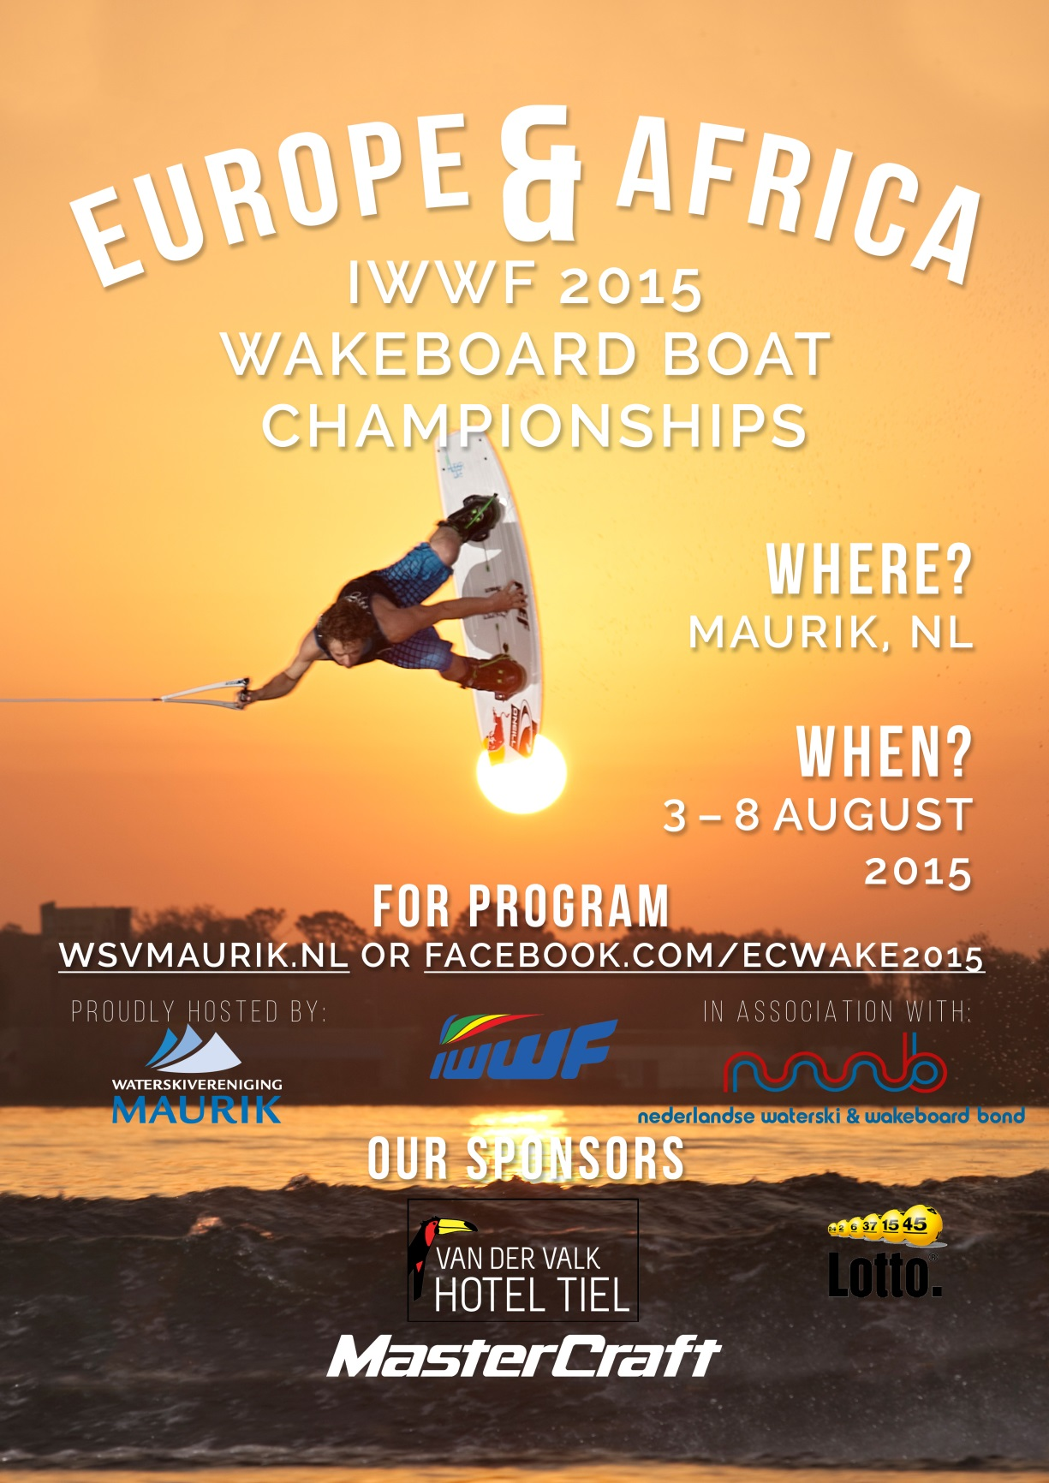
Bulletin #1
INTRODUCTION
The Dutch Water Ski and Wakeboard Federation (NWWB) would like to invite all riders from the European and African water ski federations to the
2015 IWWF - EA Wakeboard Boat Championships
which will be held in Maurik, The Netherlands.
Further information can be obtained from our website: www.wsvmaurik.nl or from the website of the Dutch federation: www.nwwb.nl.
For any further questions, please feel free to email us at info@wsvmaurik.nl or backoffice@nwwb.nl
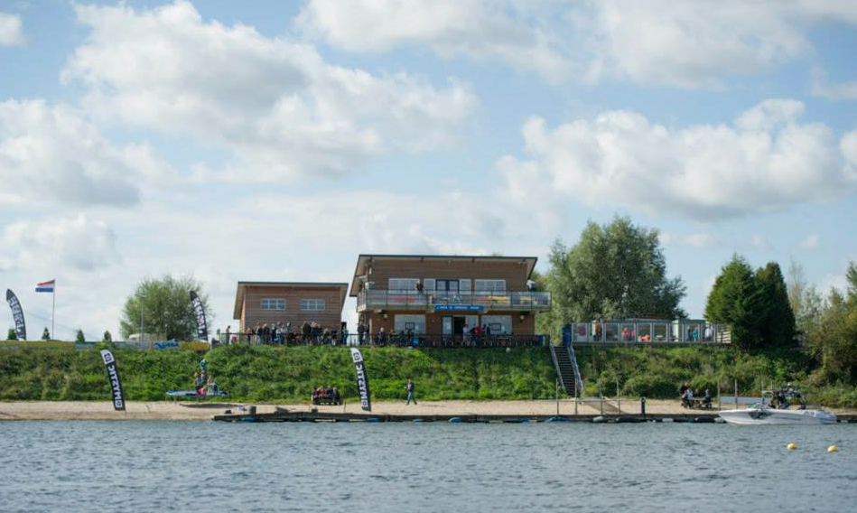
LOCATION OF THE WATERSKI & WAKEBOARD RESORT
Rijnbandijk 40 Longitude: 5.393427
4021 GH Maurik Latitude: 51.964563
The waterski and wakeboard resort is located on a formal flow path of the river Rhine which has been used for a major number of national ski-tournaments over the last 30 years, since the club WSV Maurik was established.
In 2009 the club proudly organized the European Senior Tournament Championships and in 2012 it was the European Youth Tournament Championships that was held in Maurik.
Because of the smooth sand shores, the competition area is a well sheltered against the common westerly winds and therefore suffers a minimum of waves and backwash.
OFFICIAL OPENING
The official opening will be on Monday evening, August 3rd 2015.
INTENTION TO ENTER
Each Federation shall certify to the Chairman of the IWWF Region EA Wakeboard Council and to the organizing committee, not later than June 4, being 60 days before the scheduled start of the first event of the IWWF Wakeboard EA Championships (4th of June), its intent to compete. Any Federation not meeting this requirement will not be allowed to compete until they pay a fine of € 200.00 to the IWWF.

ENTRY
Each Federation shall certify to the Chairman of the IWWF Region EA Wakeboard Council, the Chairman of the Region Wakeboard Council, and the organizing committee, not later than July 19, being fifteen (15) days before the scheduled start of the first event of the EA Championships, the names of the members of its team. Any Federation not meeting this requirement will not be allowed to compete until the Federation pays a fine of € 10.00 per rider per day after the 15-day deadline to the IWWF for each rider not officially entered.
If the official entry forms are not received prior to the 24 hours before the start of the first event, the Federation's rider's places in the draw shall be determined by the Chief Judge without reference to their qualifying scores. There is no limit on official reserves per team.
ENTRY FEE
The entry fee for the 2015 IWWF - EA Wakeboard Boat Championships is € 140.00 for girls, boys and junior divisions. It will be € 180.00 for Open and Master divisions.

COMPETITION BOAT & OBSTACLES
The Competition Boats will be a 2015 Mastercraft (Xstar). There will be obstacles in the water. We will let you know more in bulletin #2.
TRAINING ON THE RESORT
Unofficial practice is offered on Friday, July 31 to Sunday, August 2. Times for Practice are from 8:00 am till 6:00 pm on Friday and Saturday and from 8:00 am till 5:00 pm on Sunday.
UNOFFICIAL PRACTICE ON OFFICIAL WATER
Each participating Federation attending the EA 2015 championships has the
right to book 10 minutes (1 slot) for every athlete. All slots must be reserved by the team captain of the Federation consecutive. The fee for practice on the official water is € 40,- per 10 minutes. During practice on the official water, only the team captain or the team manager is allowed to get into the boat.
Detailed info about the booking procedure will follow in bulletin #2.

UNOFFICIAL PRACTICE ON NEARBY WATER
Every participating Federation to the EA 2015 championships has the right to book practice on the nearby water, with a minimum of one and a maximum of two hours. Bookings should be done at info@wsvmaurik.nl. The bookings will be granted on a first come first book bases. There will be no obstacles on this water and we cannot guarantee that we will drive the competition boat (more info will follow in bulletin #2). The fee for 1 hour of practice is € 200.00.
DRUG TESTING
Drugs and doping control will be applied during the championships.
VISA
The Organizing Committee will issue official visa invitations to all participants, officials, delegates and guests if requested. All the necessary personal information needs to be provided beforehand. VISA requests can be sent to the organizer.

HOW TO REACH US?
By car
The resort is only 20 minutes’ drive from Tiel, a town near the motorway A15. The cities Arnhem, Utrecht or Nijmegen will only take about 40 minutes’ drive.
Parking area is available on the resort.
Airports
Amsterdam Schiphol is just 1 hour away,
The Hague Airport Rotterdam 1 hour 15 minutes,
Duisburg and Düsseldorf (Germany) 1 hour 20 minutes.
TRANSPORT
The easiest option is to use a (rental)car.
The town of Tiel has a railway station, however, the resort, as well as the camping cannot be reached by public transport.
On request, transport between the airport and official hotel en between the official hotel and the resort vice versa can be provided. Payments should be done to the transport company. More information will be in bulletin #2.

CAR RENTALS
All major car rental companies have their representations at the airports.
HOTEL AND CAMPING
HOTEL
Official Riders Hotel
The official riders hotel is the Van der Valk Hotel, located beside the motorway A15 in Tiel, and is about 10 kms, 20 minutes’ drive from the resort. For photo’s or other information, please visit the website www.hoteltiel.nl.
The hotel is increasing through development from 100 to 200 rooms during the next months and will be ready in May 2015. For images of the construction see: http://www.hoteltiel.nl/nieuwbouw/nieuwbouw-in-beeld.

Please email your bookings directly to the hotel and quote the reference “Wakeboard Championship”.
Contact details: +31 344 622020
Email: tiel@valk.com
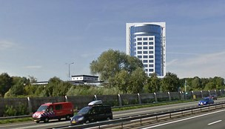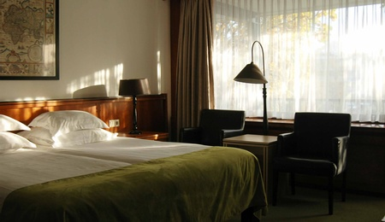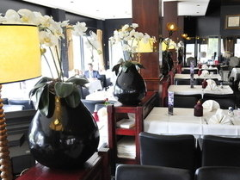
CAMPING
Unfortunately, camping on the resort is not possible. Alternatives nearby are:
- Camping “De Loswal”
This camping is located next to the resort. Please visit the website, www.camping-deloswal.nl.
Please email your bookings to info@camping-deloswal.nl
Phone +31 344 692892
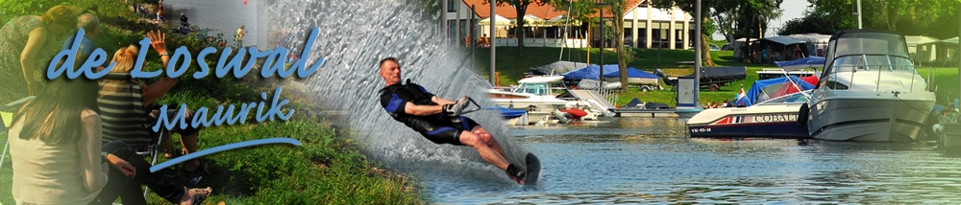
- Resort “Eiland van Maurik”
This resort can be found at 5 kilometers from the waterski and wakeboard resort and offers you the possibility to stay in a luxury tent or a cottage.
For more information, please visit www.eilandvanmaurik.nl.
Please email your bookings to receptie@eilandvanmaurik.nl.
Phone +31 344 691502
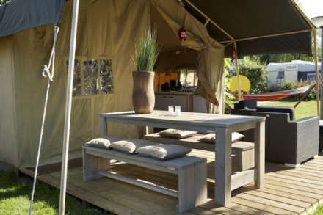
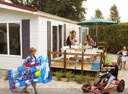
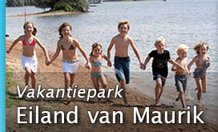

SWIMMING
Swimming is not allowed in the part of the water that is used by boats.
However, in front of the above mentioned camping’s, an area for swimmers has been reserved.
The temperature of the water will be about 20 dc.

FOOD & REFRESHMENTS
Food and refreshments will be available for reasonable prices during the whole event at the resort.

PAYMENTS
Most credit cards are well accepted in The Netherlands.

FINAL NIGHT BANQUET
All teams and officials are invited to the final night banquet.
Detailed information will follow in future bulletins.

NATIONAL FLAGS AND ANTHEMS
Each team must bring an additional flag of their country, for each medal position anticipated in the medal presentations (Size approximately 100 x 150 cm).
All teams should bring with them a USB-stick with their National Anthem.

SUPER FINAL
The EA wakeboard boat council and his main partner Mastercraft are offering a Super Final for the EA Elite Riders. This Super Final will be held at the 2015 IWWF – EA Wakeboard Boat Championships, on Friday August 7th 2015.
The following riders would be able to access to the Super Final

Pro men’s division
Top 12 Riders from 2015 EA Wakeboard pro tour Ranking list
2 Invited riders at the discretion of the Organizer
1 Invited rider at the discretion of Mastercraft Boat Company

Pro women’s division
Top 9 Riders from 2015 EA Wakeboard pro tour Ranking list
2 Invited riders at the discretion of the Organizer
1 Invited rider at the discretion of Mastercraft Boat Company
A total of 15.000 U.S. Dollars will be distributed among the Pro Men and Pro Women Podiums. Detailed information, super final rules will be distributed with the bulletin #2.

PROVISIONAL TIMETABLE
Friday July 31st and Saturday, August 1st
Unofficial practice
Sunday, August 2nd
Unofficial practice
09.00 - 17.00: Registration by the Secretariat
Monday, August 3rd
All day: Qualification round
18.00: Opening ceremony in the City Hall of Maurik
Tuesday August 4th
All day: Qualification round
Wednesday August 5th
All day: Qualification round
Thursday August 6st
All day: Qualification round
Friday August 7th
Super Final
Super Final Prize Giving
Saturday August 8th
All day: Final round
Individual Prize giving at the site
Closing Ceremony - Team Prize giving - Final Night Party
The timetable is subject to change at the discretion of the Chief Judge. All riders and team captains should pay attention to the notice boards for changes.

LlABILITY
The organizing Committee and IWWF will not be held liable for any loss or damage to equipment, personal property, injuries to athletes, officials, judges, official volunteers, and other persons attending official or unofficial programs during the event. Athletes are required to purchase and show proof of personal accident insurance prior to entry. The insurance policy must provide coverage internationally. The organizer will not be responsible for any injury sustained, at any time, by any athlete from his participation in this event. Adequate personal medical insurance coverage is necessary. Certificate of medical insurance coverage/full payment is required before medical treatment/hospitalization takes place.

USEFUL CONTACTS
• Website Dutch Water Ski Federation: www.nwwb.nl
• Email Dutch Water Ski Federation: backoffice@nwwb.nl
• Website organizer: www.wsvmaurik.nl
• Email organizer: info@wsvmaurik.nl
• Training Reservation: info@wsvmaurik.nl
• Official hotel website: www.hoteltiel.nl
• Hotel reservation: tiel@valk.com
• Official camping website: www.camping-deloswal.nl
• Camping reservation: info@camping-deloswal.nl
Further information will be in bulletin #2.
We are looking forward seeing you at our
waterski & wakeboard club in Maurik,
The Netherlands in August 2015
