2015 IWWF
EA Wakeboard Boat Championships
3-8 August, Maurik, The Netherlands
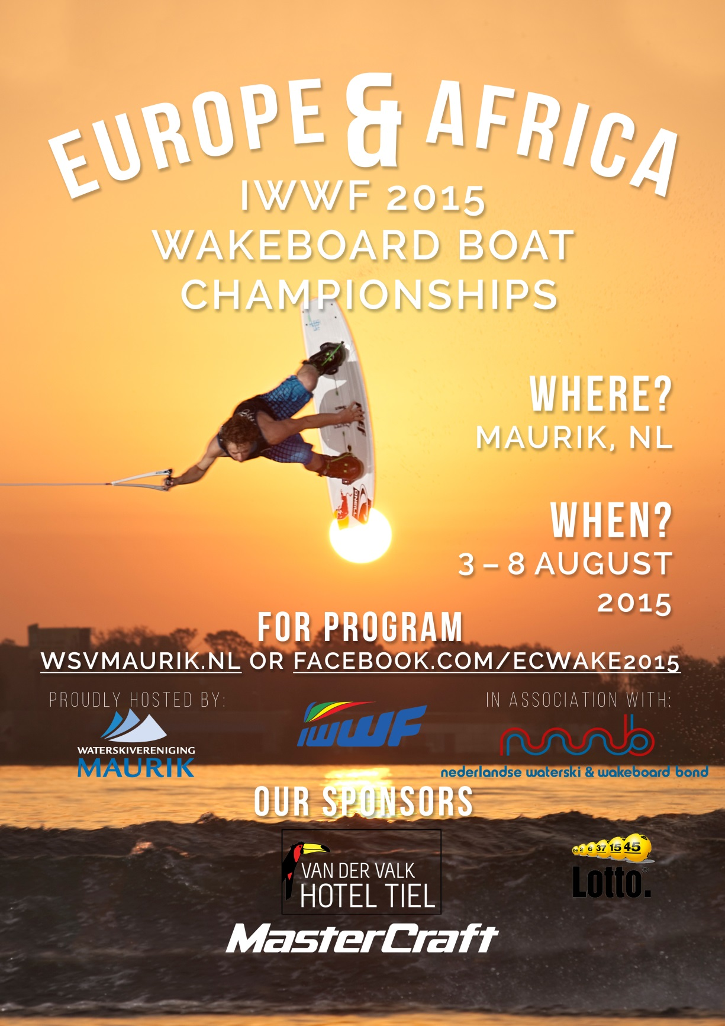
Bulletin #2
INTRODUCTION

The Dutch Water Ski and Wakeboard Federation (NWWB) welcomes all participating National Water Ski & Wakeboard Federations to the 2015 IWWF
EA Wakeboard Boat Championships to be held in Maurik, The Netherlands.

Bulletin #2 includes information about the opening, meetings, traveling, the final night banquet and more.
If there is any need for more information, please look in to Bulletin #1 which can be found on our website: www.wsvmaurik.nl.
For any further questions, please feel free to email us on info@wsvmaurik.nl. or backoffice@nwwb.nl.
LOCATION OF THE RESORT
Rijnbandijk 40
4021 GH Maurik
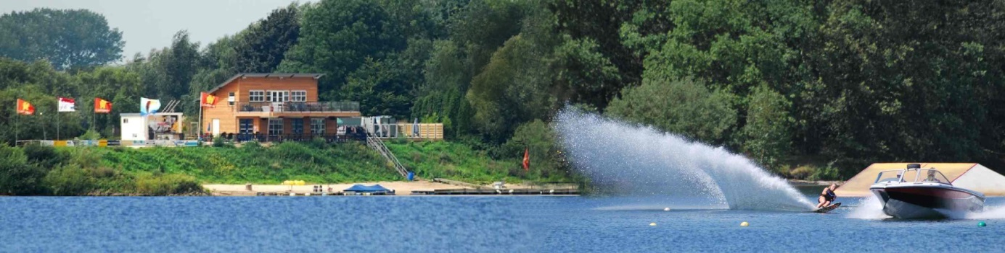
Parking
There is a 2 Euro fee for spectators. Skiers and officials park free of charge.
OFFICIAL OPENING
The official opening will be on Monday evening, August 3rd . The opening will take place at 19.00 hours at the city hall of Maurik. Drinks and sandwiches will be available.
A parade has been organized between the resort and the city hall. The parade starts at 18.00 hours from the resort.
Please, can the teams bring their country flag for the parade as well as for the opening ceremony.
Transport back to the resort has been organized.
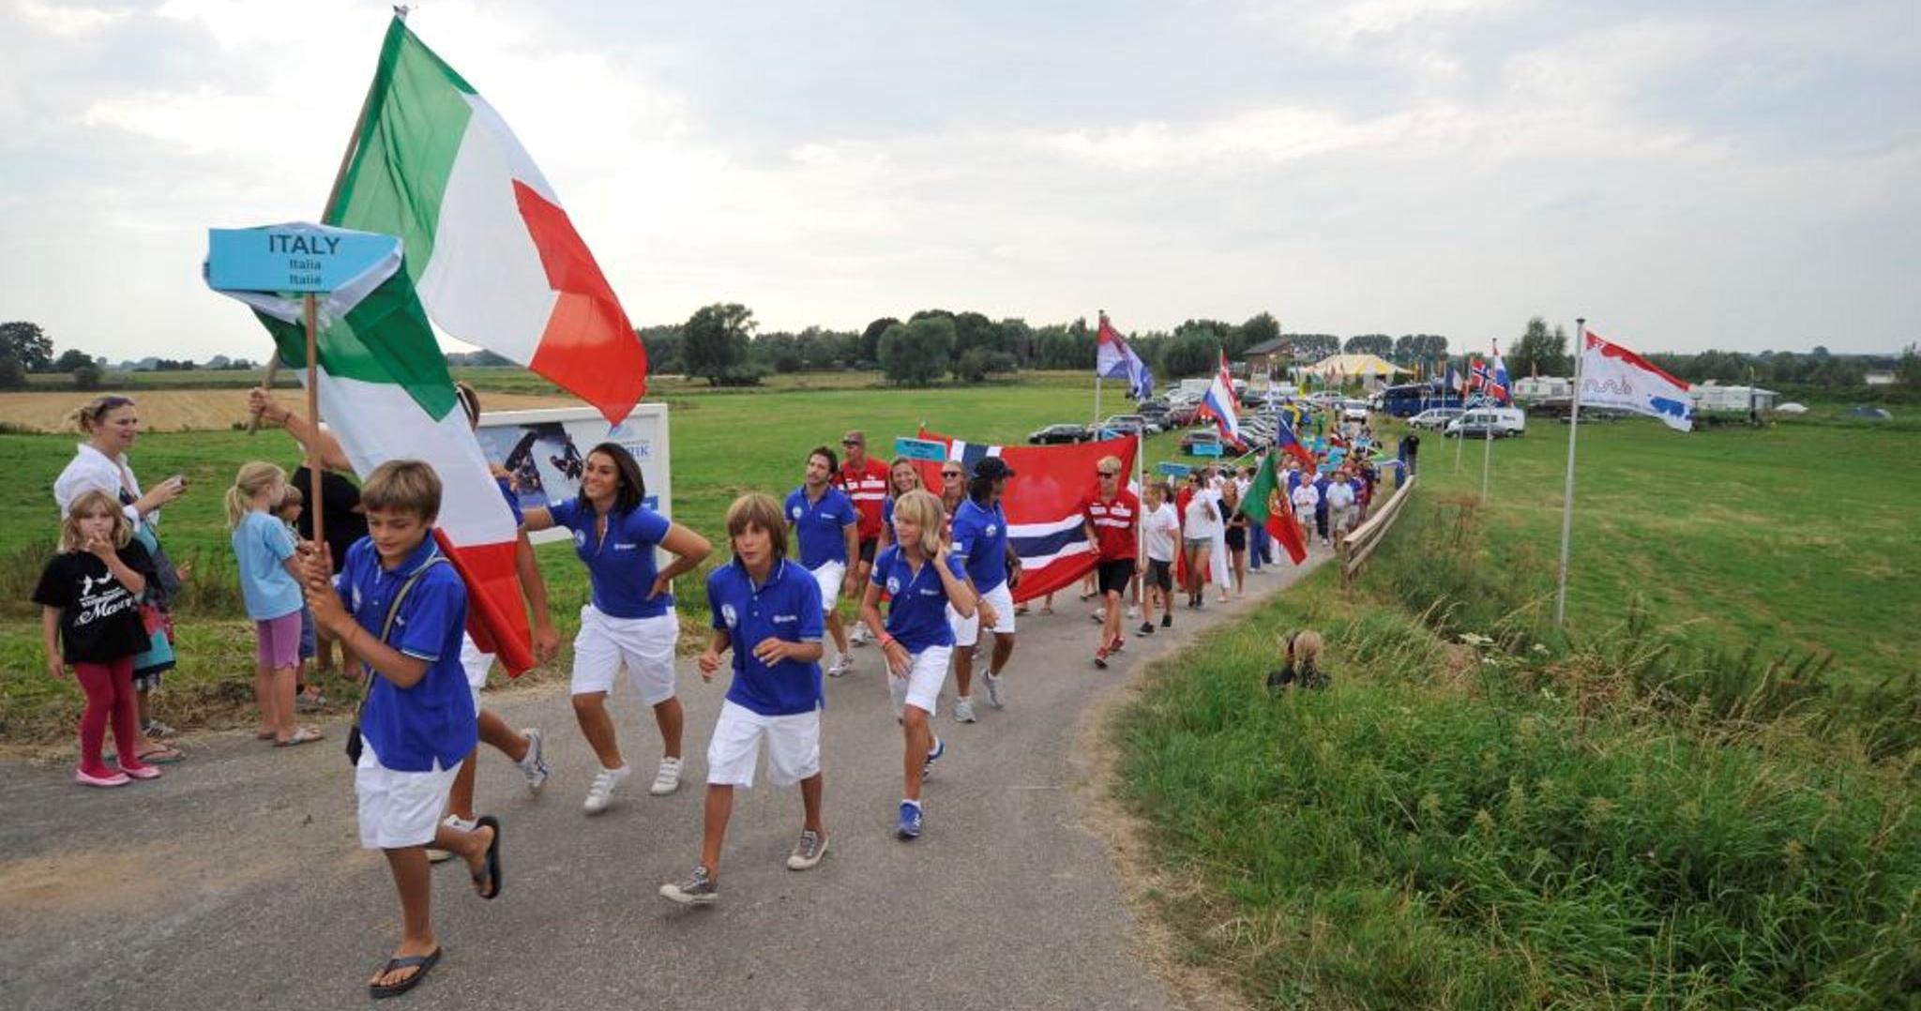
E&A Youth Championships 2012, Maurik

ENTRY
Each Federation will have to certify to the Chairman of the IWWF Region EA Wakeboard Council, the Chairman of the Region Wakeboard Council, and the organizing committee, not later than July 20, being fifteen (15) days before the scheduled start of the first event of the EA Championships, with all the names of the members of its team. Any Federation not meeting this deadline will not be allowed to compete until the Federation pays a fine of € 10.00 per rider per day after the 15-day deadline to the IWWF for each rider not officially entered.
If the official entry forms are not received prior to the 24 hours before the start of the first event, the Federation's rider's places in the draw shall be determined by the Chief Judge without reference to their qualifying scores. There is no limit on official reserves per team.

SPEAKER INFORMATION
See attachment.
Skiers and/or federations should make sure to fill in the requested speaker information and send this form together with the entry form to info@wsvmaurik.nl.
PAYMENTS
Payments for the entry fee, the training, t-shirts, lunches, final night banquet should be done on the following account of WSV MAURIK:
BIC RABONL2U - IBAN NL 98 RABO 0341 1548 57
Name and address of the bank are:
Rabobank West Betuwe
Postbus 220
NL 4000 AE Tiel
Please make sure the costs of the payments are for your own account.
ENTRY FEE
The entry fee for the 2015 IWWF - EA Wakeboard Boat Championships is € 140.00 for girls, boys and junior divisions. It will be € 180.00 for Open and Master divisions.
The entry fee is to be paid by bank transfer before July 20th 2015
mentioning “ENTRY FEE” and the name of the skier or the team.
For all details of our bank, see above.

TRAINING ON THE RESORT
Practice is offered on Friday, July 31 to Sunday, August 2. Times for practice are from 8:00 am till 6:00 pm. In case of a need, we can make Thursday, July 30, available as well.

Practice on the official water
Each participating Federation to the E & A 2015 championships has the right to reserve 6 minutes (1 slot) for every athlete. The practice offers one ride back and forth over the official course.
All bookings must be done by a Federation consecutive.
The participating countries can apply for this training starting (that is not before) midnight June 17, 2015, 0:00 am. The notification should make a statement of the number of participants in the training and the desired date and time.
The order of practice will be determined on a first come first serve basis of the reservations. The price for 1 slot of practice on the official water is 40 Euro.

Practice on public water
Every participating Federation to the E & A 2015 championships has the right to reserve practice time on nearby public water. The minimum time is one hour. The maximum time that can be booked by a Federation on one day is two hours.
Bookings will be accepted starting midnight June 17, 2015, 0:00 pm and will be granted on a first come first serve basis.
The price for 1 hour of practice on nearby water is 200 Euro.

General rules
- Practice should be reserved through info@wsvmaurik.nl.
- Sessions will not be booked until payment is received. For all details of our bank, see above.
- Exchanges in the schedule with other participants will be accepted until July 15, provided that both parties inform the organizer about the changes.
- Weather conditions or other unforeseen situations might force the organizer to cancel some slots out of the schedule. If this happens, the slots will be rescheduled after 6 pm.
- Decisions about the training schedule can be taken by the organizer and by the organizer only, at any time. The need to make the scheme as optimal as possible, can result in minor modifications of previously allotted times.

COMPETITION BOAT
The official tow-boats for the event will be Mastercraft X Star.
LIABILITY
The organizing Committee and IWWF will not be held liable for any loss of or damage to equipment, personal property, injuries to athletes, officials, judges, official volunteers, and other persons attending official or unofficial programs during the event. Athletes are required to purchase and show proof of personal accident insurance prior to entry. The insurance policy must provide coverage internationally. The organizer will not be responsible for any injury sustained, at any time, by any athlete from his participation in this event.
Adequate personal medical insurance coverage is necessary. Certificate of medical insurance coverage/full payment is required before medical treatment/hospitalization takes place.
SECURITY
Any damage resulting from misconduct will be recovered from the federation involved. Security personnel and CCTV cameras are present in the hotel and on the resort and do protect our common interests.
HOMOLOGATION
The Chief Judge will supervise and homologate the installation of the official competition Wakeboard course and obstacles.
OFFICIAL WEBSITE
We may use the respected IWWF website (www.iwwfed.com) and IWWF_WWC one (http://www.iwwfwakeboard.com/IWWF/Welcome.html) as an official website for riders & medias.
THE CHAMPIONSHIP RULES
This event uses 2015 IWWF World Wakeboard Championships rules.

ACCOMMODATION
For information about the preferred hotel and campsite, we refer to Bulletin #1 on our website.
It is not possible to camp on the resort.
Hotel rooms are limited, we strongly advice to make the necessary reservations as soon as possible.
FOOD AND DRINKS
Food and drinks are available on the resort. Lunches from a buffet can be ordered preferably before the event starts at a price of 12,50 Euro per person per day. Acceptance of bookings for the buffet during the event, cannot be guaranteed.
Sandwiches, hot and cold snacks and a wide selection of drinks are available during the day. Prices can be found on the English part of our website www.wsvmaurik.nl.

T SHIRTS
For the 2015 Wakeboard Boat European Championships we have designed a special t-shirt. Orders can be sent to info@wsvmaurik.nl mentioning the number, size and model (ladies or men).
The price during the presale is 15 Euro. The presale will run until July 3. Presale ordered shirts can be paid and obtained during the event. We can also send them with the post if you wish so (prices are excl. postage). For all details of our bank, see page 4 of this bulletin.
During the event, the price of the t-shirts will be 17.50 Euro as long as stocks last.
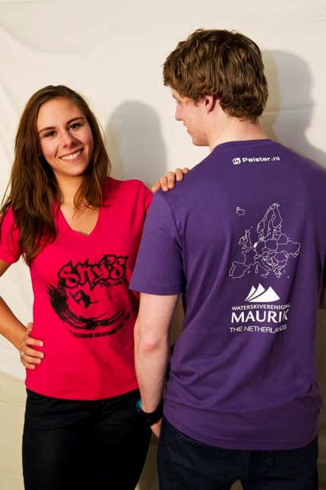
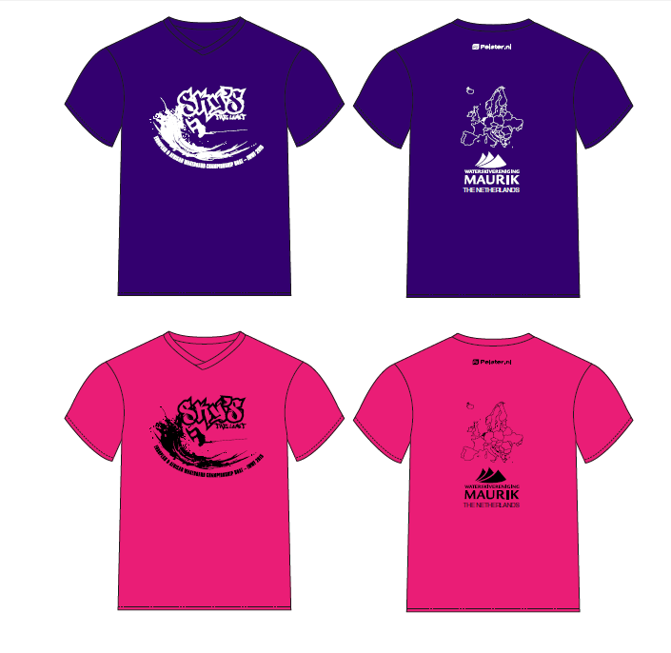

ALCOHOL AND DRUGS
According to the Dutch law, we are not allowed to offer alcoholic drinks to anyone under 18 years old. All federations are kindly asked to inform their teams about this law.
Please note that we have doping control. The use of drugs by athletes is forbidden by Dutch and International doping law. So please don't use drugs. In case of a positive doping test, all (significant!) costs will be for the rider.
MONday evening: music
Monday, August 3, following to the official opening in the city hall, WSV Maurik invites all participants, officials and club members to join us for a nice evening with music. Entrance will be free, food and drinks will be offered at reasonable prices. There is no need to make a reservation.

WEDNESDAY EVENING: ORGANISED TRIP TO AMSTERDAM
Wednesday evening , August 5th, we offer a bus trip to Amsterdam.
The schedule is as following:
19.00: Departure from the riders hotel
20.00: Buffet, two drinks are included
21.30 – 23.00: Boat trip through the channels
01.00: Departure from Amsterdam
02.00: Arrival at the hotel

Costs : 65 Euro per person.

There should be at least 40 entries to make the trip happen.
Bookings will be done on a first come first serve basis.
Departure of the bus will be strictly adhered to. Latecomers travel further on their own.

Bookings can be made on info@wsvmaurik.nl.
The booking will be confirmed after the receipt of the payment.
Payment of the Amsterdam trip should be done on the account of WSV MAURIK. (see page 4 of this bulletin), mentioning “Amsterdam trip”, and the number and names of the participants.
Bookings can be accepted till July 19, 2015.

SATURDAY evening: Final night banquet
All participants, officials and club members are invited to the final night barbecue on Saturday evening, August 8.
The team medals will be awarded during this party.
The barbecue will take place on the resort. We will offer a wide choice of meats and salads. The costs will be 30 Euros per person for unlimited food and music. Drinks however are not included.
Due to the catering it is compulsory to make a reservation. Closing date is August 3. After this date the organizer cannot guarantee tickets will still be available.
Reservations can be made by e-mail to info@wsvmaurik.nl.
Please note: payment for the barbeque must be received not later than August 3 in cash or at the bank account as mentioned on page 4 of this bulletin.
LOCAL TRANSPORT
The area of Maurik can easily be reached by (rental)car.
The official hotel is located in the town of Tiel. Tiel has a train station and you will need additional transport to travel the 2 kms between the train station and the hotel.
The resort, as well as the campsites, cannot be reached by public transport.
In case of travelling by train directly to the resort or to the preferred campsites, we would like to advise to stop at the train station in Culemborg and get a taxi from there to the resort.
CAR RENTALS
All major car rental companies have got their own representatives at the airports.
We have not made any special arrangements with specific rental companies but we can advise the following: www.europcar.nl; www.hertz.nl; www.budget.nl; www.sixt.nl; www.avis.nl
FOR THOSE TRAVELLING BY (RENTAL) CAR
Hotel Tiel is 88 kms from Amsterdam airport, it will take approx. 60 to 90 minutes drive, depending on the traffic.
The resort is 10 kms away from the hotel. This will take about 15 minutes by car.
From the hotel choose destination “Maurik ”on the N835 and then “Eiland van Maurik”.
You will arrive on the dike by the river. Turn left and follow the dike for 3 kms. You will pass a marina and the campsite “De Loswal” on your right hand side. The resort is just west from the campsite.

NOTE: the address of the resort (Rijnbandijk 40) is very recent and cannot be found on most route planners.
We suggest to use the address of the preferred campsite “De Loswal”: Rijnbandijk 36, 4021GH Maurik.
The coordinates of the site are 51°57'46.5"N 5°23'45.8"E.
any QUESTIONS?
During the competition, there will be a help desk located at the clubhouse.
Our general manager during the competition is mr Ton van der Giessen, his mobile phone number is: 0031 (0)6 53145858. During the event you can call him at any time between 8.00 and 21.00 hours.
FLAGS & ANTHEMS
- Each team must bring an additional flag of their country, for each medal position anticipated in the medal presentations (size 150 x 225 cm).
  - Concerning the national anthems, the Organizing Committee would like to ask the teams to bring their national anthem on a CD or mp3.
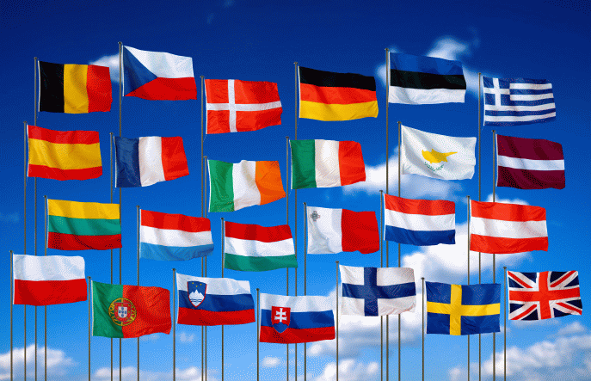
USEFUL CONTACTS
• Website Dutch Water Ski Federation: www.nwwb.nl
• Email Dutch Water Ski Federation: backoffice@nwwb.nl
• Website organizer: www.wsvmaurik.nl
• Email organizer: info@wsvmaurik.nl
• Training Reservation: info@wsvmaurik.nl
• Official hotel website: www.hoteltiel.nl
• Hotel reservation: tiel@valk.com
• Official camping website: www.camping-deloswal.nl
• Camping reservation: info@camping-deloswal.nl
• Camping or cottage reservation: www.eilandvanmaurik.nl

Important dates
June 17: Starting this date, bookings for training will be accepted.
July 20: Not later than this date, entry fees have to be paid.
July 3: Last day of the presale of the special t-shirt
July 3: Last day for booking the Amsterdam trip.
July 20: Not later than this date , the Chairman of the IWWF Region EA Wakeboard Council, the Chairman of the Region Wakeboard Council, and the organizing committee have to be informed about all the names of the members of the teams.
August 3: Reservations for the final night BBQ have to be confirmed by the payment.
Sponsors
Hotel Tiel
Camping Eiland van Maurik
Bredenoord aggregaten
GMB Beheer B.V.

We look forward to welcoming you in Maurik,
The Netherlands, July 2015
